**Assignment 4:**

→ Create a local branch using git checkout -b branchname command



→ Observe the difference by doing some file operations and switch back to the master branch and see if you can see the changes done on the branch

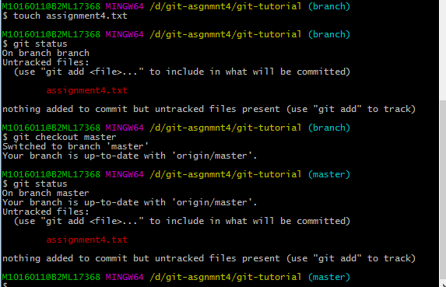

→ Now switch back to the branch and commit the changes and switch to master branch. Now see if you can still see the changes in the master branch

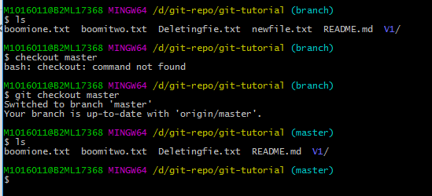

→ Now switch back to the branch name and stash the changes and apply the changes to the master branch by switching to the master branch

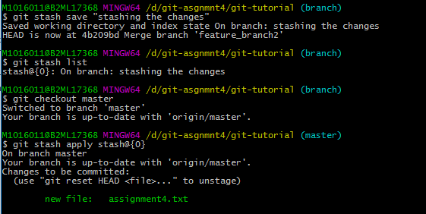

→ Try merging the changes from the branch to the master branch using all the three merge strategies and then view the git log

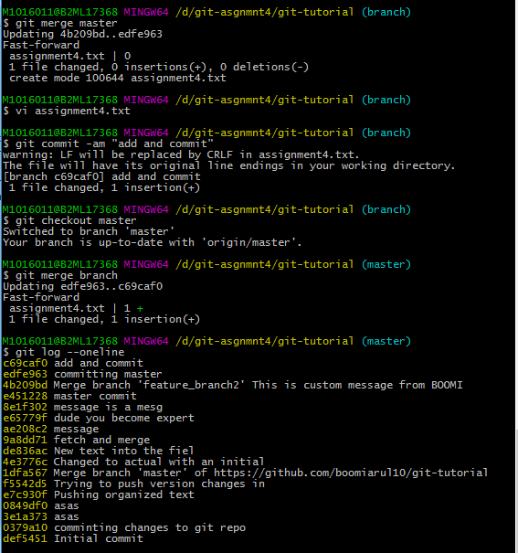

→ Push the local branch to the remote repository and see if the branch is present on the remote repository – Github

